

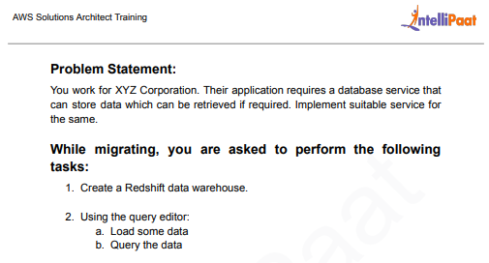

Solution: 1) Create workgroup and namespace Name of the workgroup: salman-wg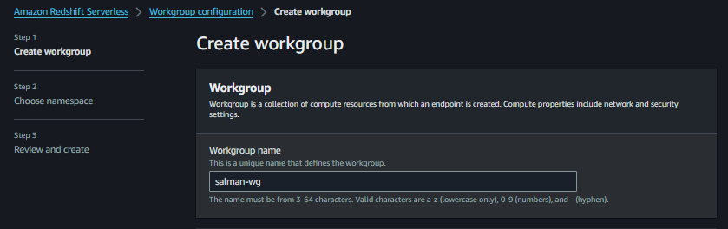

Namespace: salman-ns

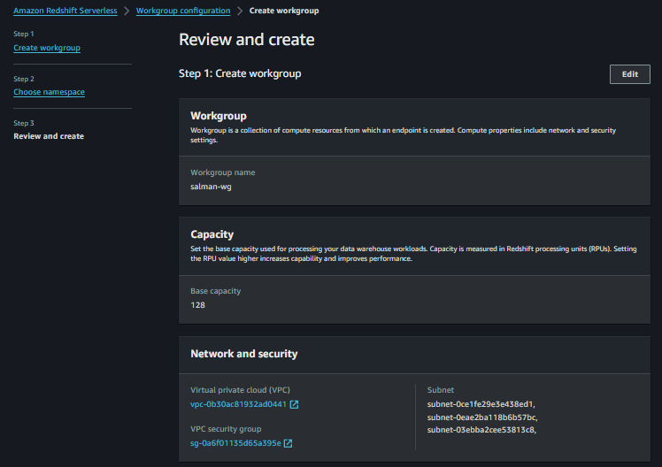

1. Review the workgroup and namespace and create it.

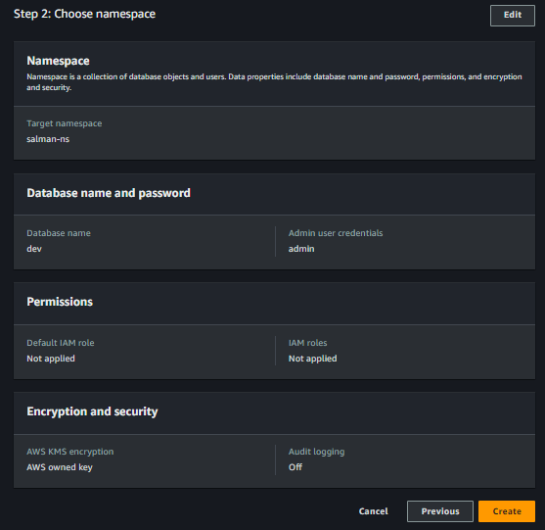

1. Workgroup and namespace created successfully.

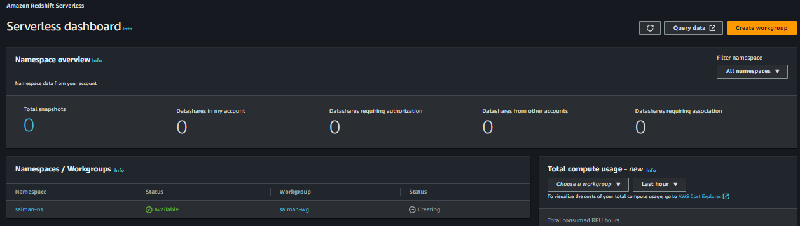

1. Now we will create the s3 bucket and other options we will choose as default and upload the csv file in our bucket.

Name: salman-redshift-bucket

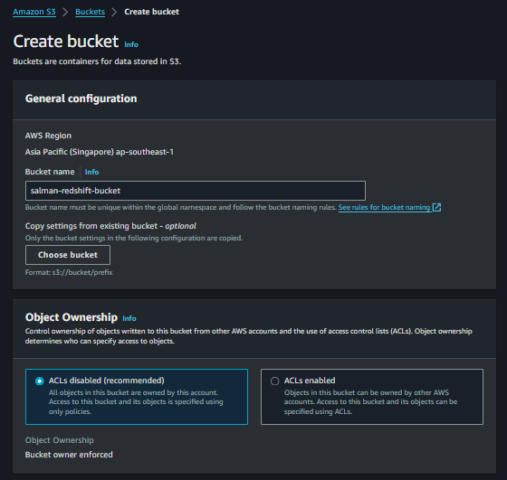

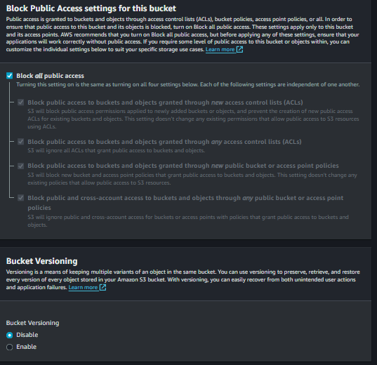

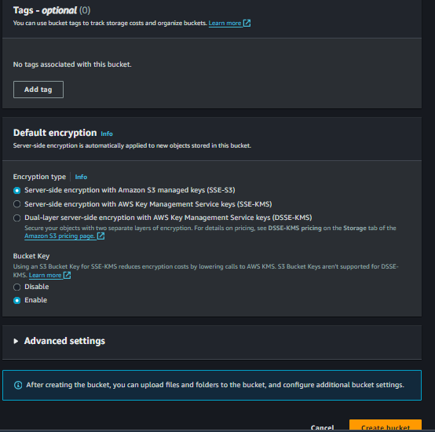

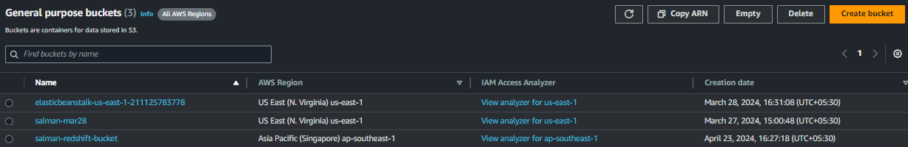

1. Upload csv file in our bucket.

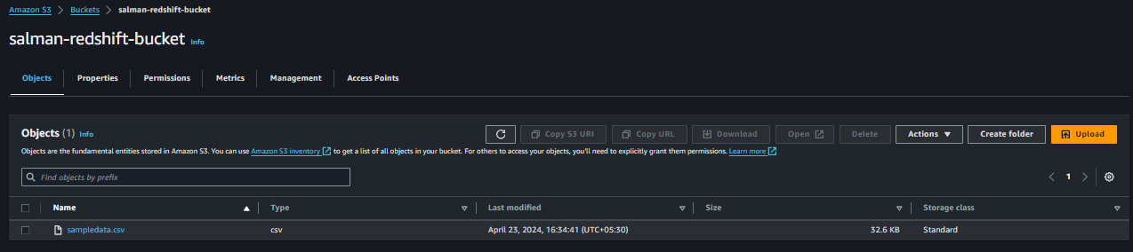

1. Create IAM role and in service or use case we will choose Redshift

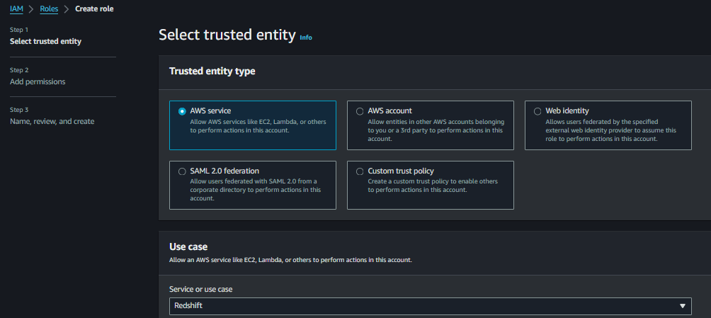

1. & Redshift-Customizable.

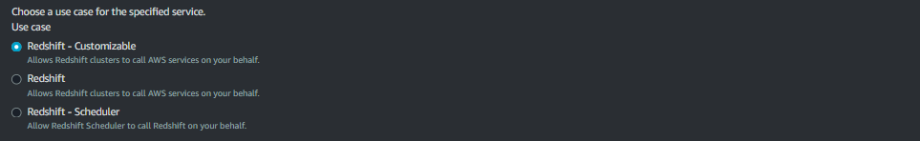

1. Give a role as salman-redshift-role.

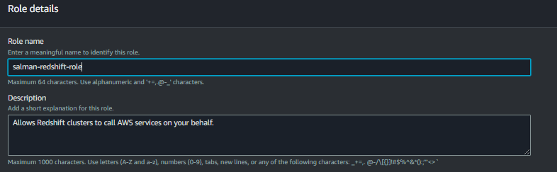

permissions

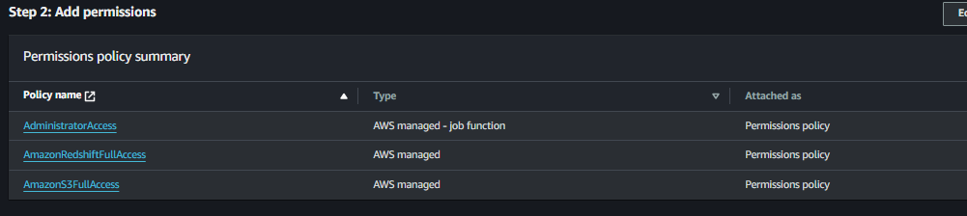

Successfully created

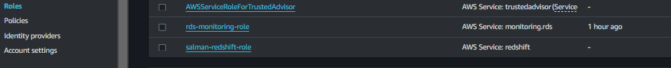

1. We will go to amazon redshift and click on query editor.
2. Click on Serverless:salman-wg and connect to salman-wg and choose Federated user and click on create connection.

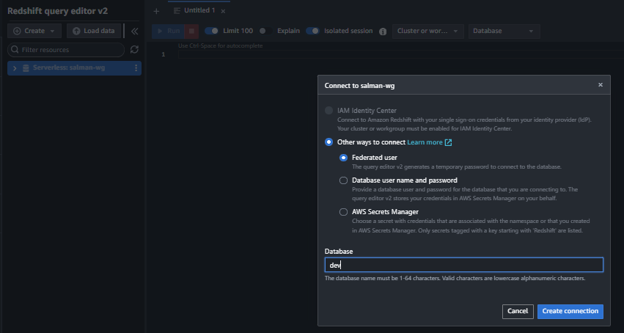

1. Click on Dev and public and right now we have 0 tables in public. Click on load data.

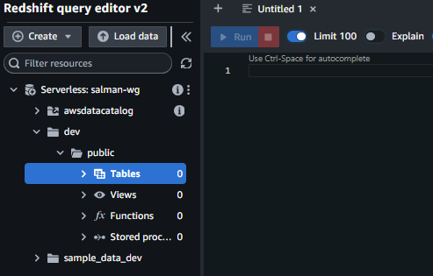

1. We will load data from our s3 bucket. Choose load from s3 bucket, region-us-east-1.

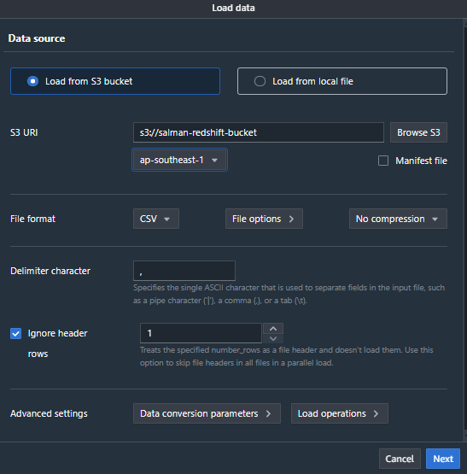

1. Next and click on load new table. In schema choose public and table name is “sample” and choose IAM Role which we created.

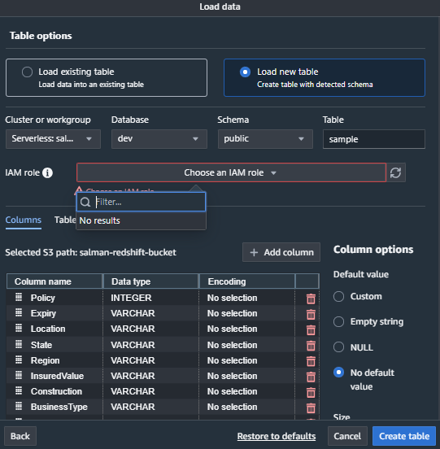

|  |  |
| --- | --- |
| Note: Created IAM Role still not available so we need to associate our IAM Role in namespace | |
| configuration. |  |

1. Go to namespace configuration
2. Click on security & encryption tab and click on Manage IAM Role

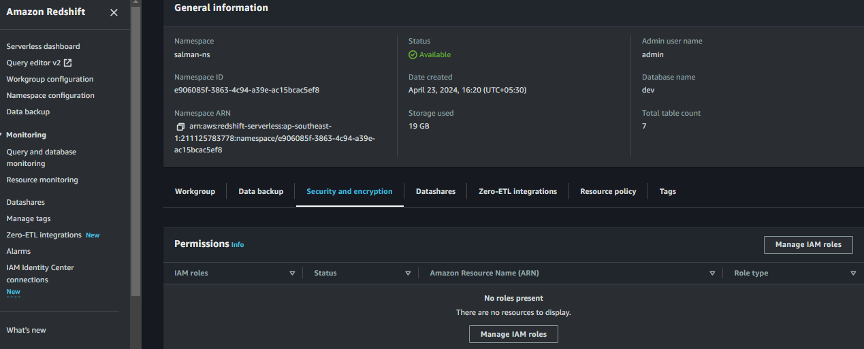

1. Click on associate IAM role and make it default.
2. Choose IAM Role which we created and click on associate IAM Role.

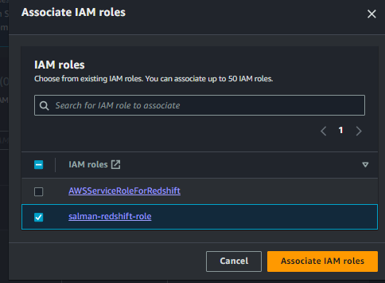

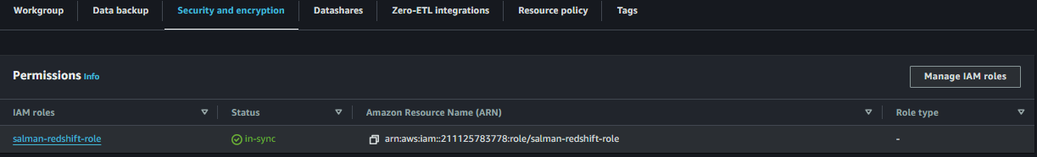

1. Now our IAM role is reflecting when loading the data.

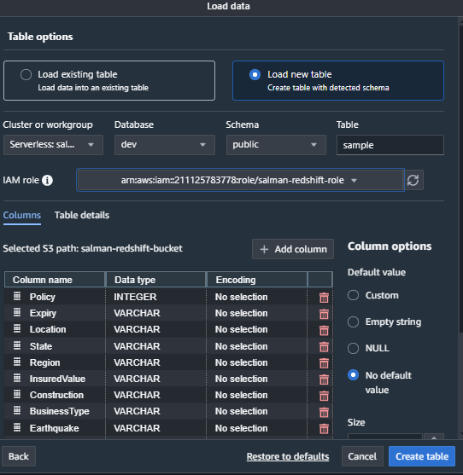

1. We will update the IAM role and click on create table and our insurance table created successfully.
2. Review and load Data and our data is now loaded successfully.

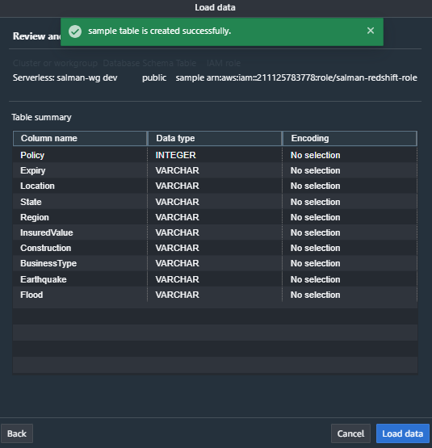

1. Now our table is showing under public.

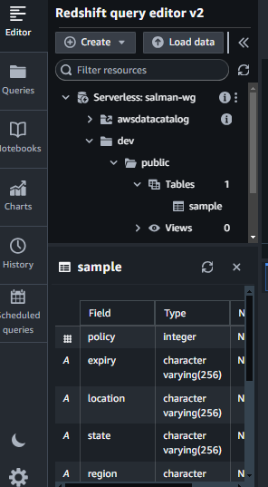

1. We will right click on the table and click on select table.
2. We will uncheck the limit and click on Run.
3. It is now showing all our 500 rows data.

